**Review Worksheet ANSWERS: PNS – Motor and Reflexes**

1: State the function of the motor division of the PNS and name the two main subdivisions:

(2 marks)

*The motor division takes signals from the CNS to the body (effectors) (1). The two main subdivisions are somatic (0.5) and autonomic (0.5).*

2: What type of tissue is controlled by:

1. The **somatic** motor PNS – *skeletal muscle (1)*
2. The **autonomic**motor PNS – *muscle of internal organs, and glands (1)*

3: What are the two subdivisions of the autonomic motor PNS?

(2 marks)

*Sympathetic and Parasympathetic*

4: Which subdivision of the PNS do I belong to?

“I release ACh at the tissues and have no synapses outside of the CNS”

*Somatic Motor PNS*

“I release ACh at the ganglion synapse, then NAdr (NEpi) at the tissues”

*Sympathetic branch of Autonomic Motor PNS*

“I release ACh at the tissues and my neurons have one synapse outside of the CNS” *Parasympathetic branch of Autonomic Motor PNS*

“My synapses outside of the CNS are organised in ganglia close to the spinal column”

*Sympathetic branch of Autonomic Motor PNS*

“My neurons outside of the CNS are pseudounipolar”

*Sensory PNS*

“I release ACh at ganglia close to the effector tissue”

*Parasympathetic branch of Autonomic Motor PNS*

“I release ACh at a gland that produces Adr and NAdr”

*Sympathetic branch of Autonomic Motor PNS*

“I connect to the spinal cord via the dorsal root”

*Sensory PNS*

“I am often under voluntary control”

*Somatic Motor PNS*

“I run through the ventral roots of the spinal cord along most of the vertebral column and have one synapse outside the CNS”

*Sympathetic branch of Autonomic Motor PNS*

“My cell bodies are in the dorsal root ganglion”

*Sensory PNS*

“My neurons exit the spinal column mostly from the brainstem, and the base of the spinal cord, not from between vertebrae”

*Parasympathetic branch of Autonomic Motor PNS*

5: Define the term “reflex” and list the four properties of reflexes

(5 marks)

*A reflex is a rapid, involuntary response to change(1)*

*The four properties of reflexes are:*

*A stimulus is required (1)*

*They are involuntary (1)*

*They are rapid (1)*

*They are stereotyped (1) which means they occur the same way each time.*

6: What is the function of reflexes?

(1 mark)

*The function of reflexes is to protect the body from injury (1) and to maintain homeostasis (1)*

7: Draw in a reflex arc on the diagram below, and label all structures and features.

(12 marks)

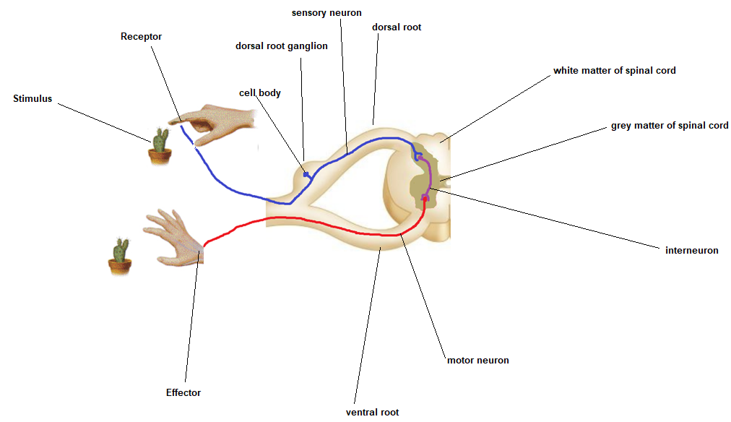



8: Draw an annotated flow diagram showing regulation of cortisol production in the body

(6 marks: 0.5 marks per feature)

